Java 8
Why Java 8? Main agenda behind Java 8
- Significant reason for Introducing Java 8 was to introduce Conciseness in the code.
- Java brings in Functional programming which is enabled by Lambda expressions ( a powerful tool to create concise code base).
- If you have ever observed, With Python, Scala we can do the same thing in Very Less LOC. By mid-20’s Java lost large market due to these languages. To prevent further loss Java upgraded itself from Only OOPs Language to some concepts of FP to create concise code base.
New Features
- Lambda Expression
- Stream API
- Default and Static methods in Interface
- Functional Interface
- Method references & Constructor references
- Optional
- Date API
- Nashron, JavaScript Engine
Main Advantages
- Compact Code (Less boilerplate code)
- More readable and reusable code
- More testable code
- Parallel operations
What is lambda expression?
- Lambda expression is an anonymous function (without name, return type and access modifier and having one lambda (->) symbol)
- E.g Normal programming function
Public void add(int a, int b){
System.out.println(a+b);
}

Lambda expression function
(a, b) -> System.out.println(a+b);
The 3 lines of code written in single Line. If only one line is applicable for method body, then parenthesis is not required.
Ex: LambdaDemo.java
What are Functional Interfaces?
- Functional Interfaces are those interfaces which can have only one abstract method
- It can have any number of static methods, default methods. No restriction on that.
- There are many functional interfaces are already present in java. Ex. Runnable, Callable, Remote, Comparable etc.
Can you create your own Functional Interface?
Create an Interface with below conditions
- Add annotation @FunctionalInterface to declare this as Functional
- Add only one abstract method in the interface
- We can have any number of static or default methods.
What is method reference in Java 8?
- Method reference is replacement of lambda expression. It is used to refer method of Functional interface to an existing method. Mainly it is used for code reusability.
- Functional Interface abstract method can be mapped to specific existing method using colon operator (: :). This is method reference.
- Whenever we have existing implementation of Functional Interface then we can go for method reference.
- 3 types of Method reference – static method reference, non-static method reference and Constructor reference
- Static method ref Syntax - className :: methodName
- Non-static method ref - ObjectName :: methodName or new ClassName :: methodName
- Constructor method ref – className :: new
Ex: MethodReferenceDemo.java
What is default method in Interface?
- Default method is a way of adding new methods to the interface without affecting the implementing classes. Hence this new feature Java people defended many compile time errors may arise due to unimplemented method of interface.
- The use of these default methods is “Backward Compatibility” which means if JDK modifies any interface (without default method) then the classes which implement this interface will break
- On the other hand if you add the default method in interface then you will be able to provide the default implementation. This won’t affect the implementing classes.
Is it necessary to override default methods?
- Default methods have dummy implementations
- Implementing class is ok with dummy implementation then use dummy implementation of default methods.
- If not satisfied then they can override and provide their own implementation
- Override annotations is important to override default method. If not added then the compiler treats that as a normal method.
Is default keyword one of the access modifier?
- Default is not the access modifier like public or private or protected.
- For default access modifier we don’t use any keyword.
- Hence default keyword was only used in classes till 1.8 version for switch case only but never in interface.
- Now its used for default methods in interface to provide a default implementation for all implementing classes to use.
How to override default methods?
- You can override default method by keeping the same method signature (name + arguments)
- Removing default keywords because in class keyword default in used switch case to denote default case if no previous matches is matched. So you cant use default keyword in class.
- Adding public as access modifier bcz in java 8, by default all methods are public so u cant reduce visibility of overridden default method.
- Giving our own implementation.
Can you use hashcode() default implementation in Interface?
- You cannot give your default implementation of hash code() in interface for all implementing classes to use
- We are not allowed to override Object class’s method as default method in interface else will get compile time error.
- All implementing classes by default has access to all the methods of Object class.
How default methods in interface cope up with Diamond problem?
- Diamond problem of default methods of Interface:
- If 2 implemented interfaces contains same default methods then that’s the diamond problem.
- In java, in such situation the code will not compile.
- Solution to Diamond problem:
Use IntefaceName.super.methodName();
Why static methods were introduced in Java 8?
- Only reason for introducing static methods in interface is that you can call those methods with just interface name. No need to create class and then its object.
- Since Interface never contain:
- Constructors
- Static blocks,
- Nothings costly in terms of memory and performance.
- Hence we don’t need to create object and hence if you have everything as static then go for interface rather than class.
Are Static methods available to implementing classes by default?
- Static methods are not available to implementing classes.
- They are not default methods. They are static.
- Hence you can call these methods using Interface name explicitly from the implementing class as implementing classes wont have access to these methods directly. (This is the disadvantage of static methods of interface that it is not available to implementing classes).

What are Predicates?
- Predicate is a pre-defined functional interface (Having only 1 abstract method)
- The only method of predicate is test(T t);
public boolean test(T t);
- Whenever we want to check any Boolean condition then go for predicates
Type Parameter and return types of Predicates?
- Input to Predicate can be anything like
  - Predicate<String>
  - Predicate<Integer>
  - Predicate<Employee> -- custom class
- Hence only one type argument is required which is input type
- Return type is not required as it return always Boolean only.
Advantage of Predicates?
- Code Reusability
- If you have same conditions being used 100 times in a program then you can write once and just use 100 times with checkLength.test(“xxx”)
- Conditional checks are holed by Functional interfaces.
What is Predicate Joining?
- You can combine predicates in serial predicate
- Three ways to join : 1.And 2. Or 3. Negate
- Ex if you want to test 2 conditions: To check length of string to check if length is even.
Ex: PredicateDemo.java
What are Functions
- Function is also a predefined Functional Interface (Having only 1 abstract method).
- The only abstract method of Function is apply(T t); R apply(T t);
- Given some input perform some operation on input and then produce / return result (not necessary a Boolean value).
- This takes 1 input and returns one output.
- In predicate we used to take 1 input and return type is always Boolean.
- In function return type is not fixed hence we declare both input type and return type.
What is Functional Chaining?
- We can combine / chain multiple functions together with andThen .
- There are two ways to combine functions:
f1.andThen(f2).apply(Input); - first f1 then f2 f1.compose(f2).apply(Input) - first f2 then f1
- Multiple functions can be chained together like : f1.andThen(f2).andThen(f3).andThen(f4).apply(Inputs);
What is Consumer?
- It will consume Item. Consumers never return anything (never supply), they just consume.
- accept(T t) is the method available in Consumer
What is Consumer Chaining?
- We can combine / chain multiple consumers together with andThen.
- There is only one way to combine consumers:
- c1.andThen(c2).apply(Input); - first c1 then c2
- No compose() in consumer.
- Multiple consumers can be chained together like: c1.andThen(c2).andThen(c3).andThen(c4).apply(Inputs);
What is Supplier?
- It will just supply required objects and will not take any input Its always going to supply never consume / take any input.
- Ex: always supply me current date.
- No chaining as no input is given to this. Only it gives u output.
Advantages of Supplier?
- Write once, use anywhere.
- Code Reusability
Use of BiConsumer, BiFunction, BiPredicate and Why no BiSupplier?
- Till now we had:
- Predicate<T> test(T t) -> return Boolean
- Function<T, R> apply() -> return anything
- Consumer<T> accept() -> return nothing
- Supplier<R> get() -> returns anything but no input
- What if we need 2 arguments for operation?
- Then we need Bi XYZ Functional Interfaces.
- There is no input in supplier so no 1 or 2 arguments are needed. Hence no supplier.
If we want to operate on 3 arguments then triPredicate?
- There are no TriPredicate or TriFunction etc.
- No QuadPredicate No QuadFunction.
- Java 8 has inbuilt Functional interfaces that can take only 1 or 2 arguments no more.
What are Streams?
- If we want to process bulk objects of collection then go for streams.
- Way to operate on collection in java 8 is Stream.
- It’s a special iterator class that allows processing collections of objects in a functional manner.
- Ex: fetch all objects from collection of lists whose value is greater than 15
List<Integer> numbers=Arrays.asList(10,15,20,25);
numbers.stream().filter(x->x>=15). foreach(System.out::println);
Why streams were introduced in java 8 if we already had java.io.stream?
- Java io streams is a sequence of characters or binary data which is used to be written to a file or to read data from a file.
- While streams java 1.8 is nowhere related to files, its related to collection object.
- Java io streams related to file whereas java 8 streams are related to collection object.
- Hence if we need to perform some operations on collection there we should go for streams.

Difference between Collection & Streams
- To represent group of collection as single entity then we should use collection concept.
- If we want to perform operation on bulk objects in collection then we should go for Streams.
Steps to create Streams?
- We can get stream object by:
- Stream s = collectionObject.stream();
- Once we get stream object we can process the object of collection.
- Processing of stream consists of 2 steps/ stages
  - Configuration of stream & processing that configuration
- Configuration can be done by Map, Filter
How to Map Stream Objects?
- What if we don’t want to filter out.
- We rather want to create new object against each existing stream object based on some function.
- EG in given stream create new object by squaring its value
List<Integer> numbers = Arrays.asList(5,10,25);
numbers.stream().map(x -> x*x).foreach(x -> System.out.println(x);
Difference between filter and Map?
- If we want to fetch / filter objects from collection like eg : filter only even numbers from array list collection the use Filter for configuration of stream.
- If we want to perform some operation on each object of the collection then create another mapped object with different value (after operation is performed) for each object of that collection, then use map.
- In filter, because of filtering, number of objects in filtered list is less than original list While in Map same number of objects are there in both new and original list created.
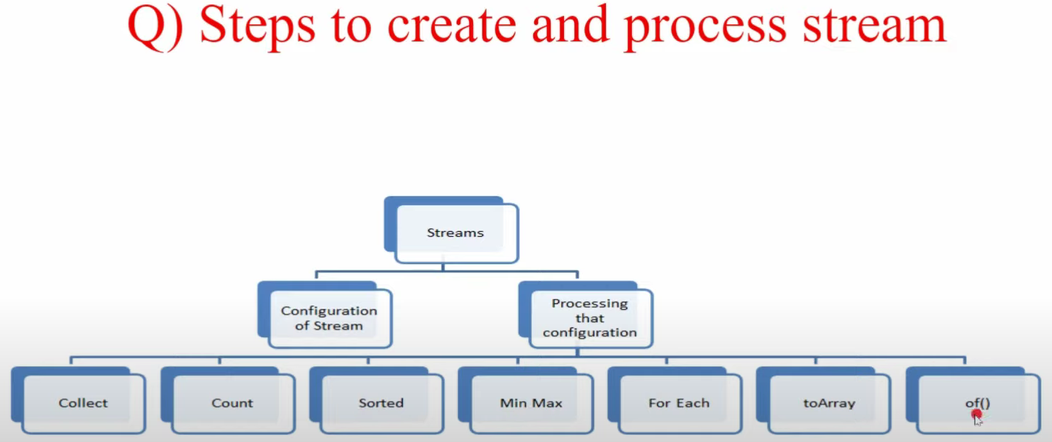
Stream Processing
Collect - If we want to collect elements of stream after filtering or mapping and add them to the required collection then use collect method.
Count - If we want to count how many elements are there in collection that satisfy given condition then use count method.
Ex. Numbers.stream().count(); -- Count total elements in List
numbers.stream().filter(i->i>15).count(); --count total elements which satisfy the condition
sorted – If we want to sort elements inside a stream then use this sorted() method. We can sort based on default natural soring order. If we want to sort using customized sorting then use comparator.
Numbers.stream().sorted(); -- Sort the elements in natural order
Numbers.stream().sorted((i1, i2)-> i2.compareTo(i1)); --Sort in descending
Comparator - If we want to sort using customized sorting order then use comparator.
Foreach() method in Stream
- All methods that we saw till now returned something, like min max value, sorted collection, etc
- This method does not return anything.
- Rather This method takes lambda expression as argument and apply that lambda expression to each element present in that stream.
How to process elements using toArray()
- We can use this method to copy elements present in the stream to specified array.
- The toarray() method returns only the Object. We have to convert to our required type by casting.
How to process elements using of()
- Stream concept is not applicable just for collections it’s also applicable for “Any Group of Value”
- Even for arrays you can use stream
- Stream.of() this method takes any group of values and convert them into stream so that multiple stream operations can be applied to it.
E.g Stream<Integer> numbers = Stream.of(1, 11,111,200);
numbers.foreach(x -> System.out.println(x));
E.g String[] name ={“code”, “decode”, “demos”};
Stream<String> names = Stream.of(name) ;
Names.filter(x -> x.length() > 4).foreach(System.out::println);

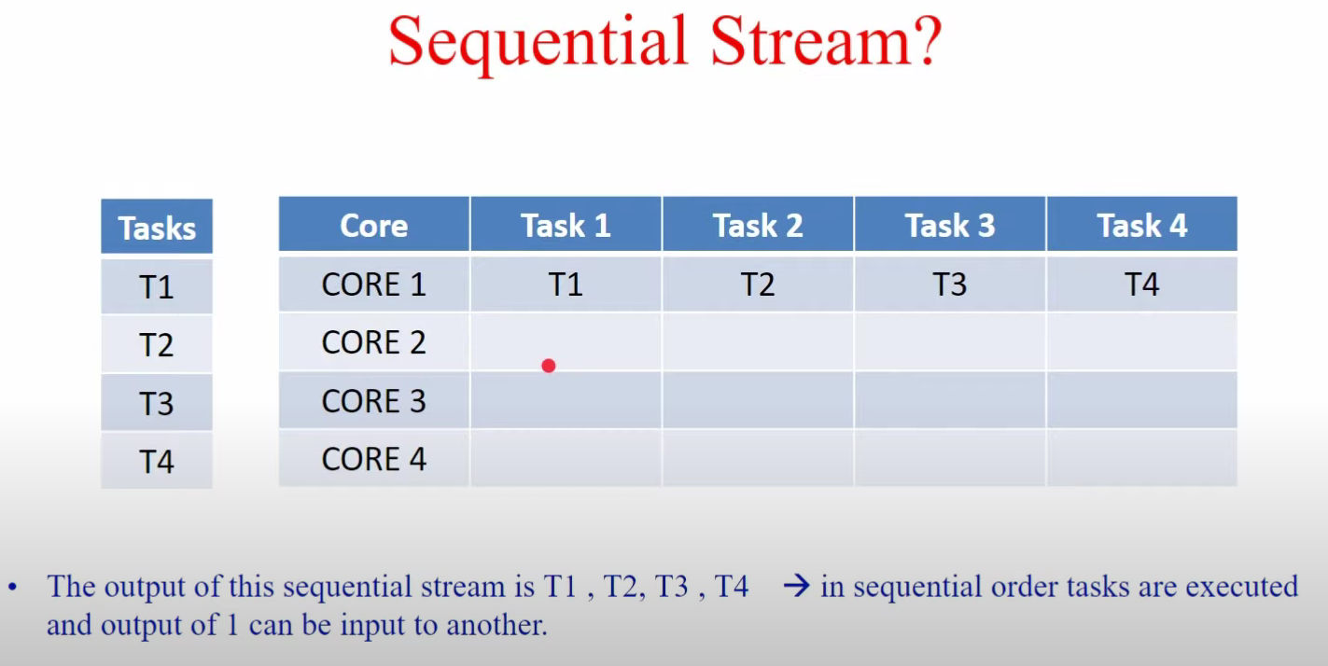
The problem is we are not using all the cores effectively so performance is bad and the memory utilization is bad. So, timing will increase.

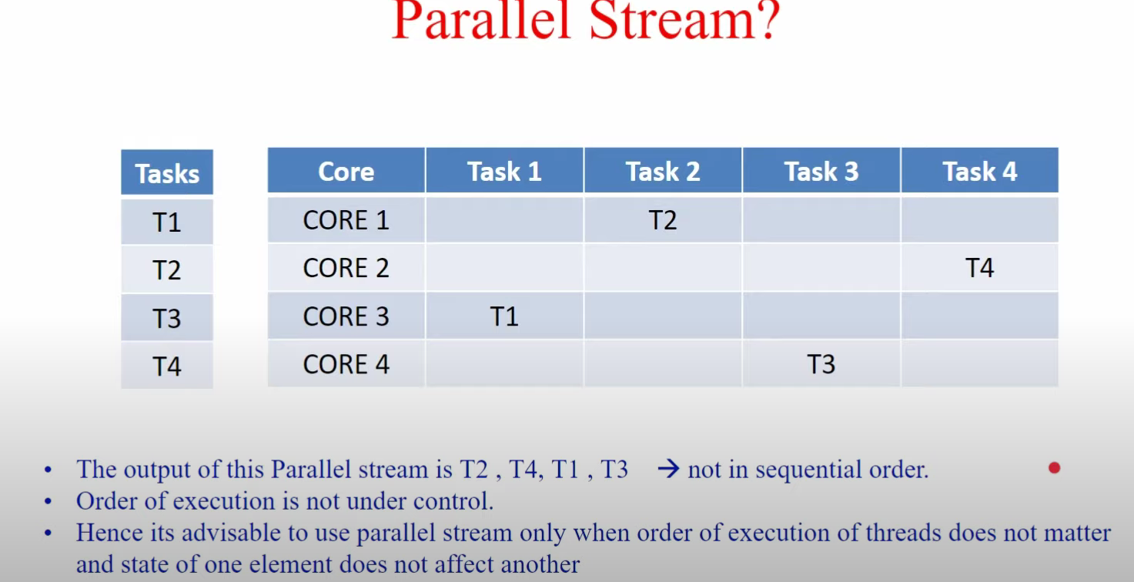
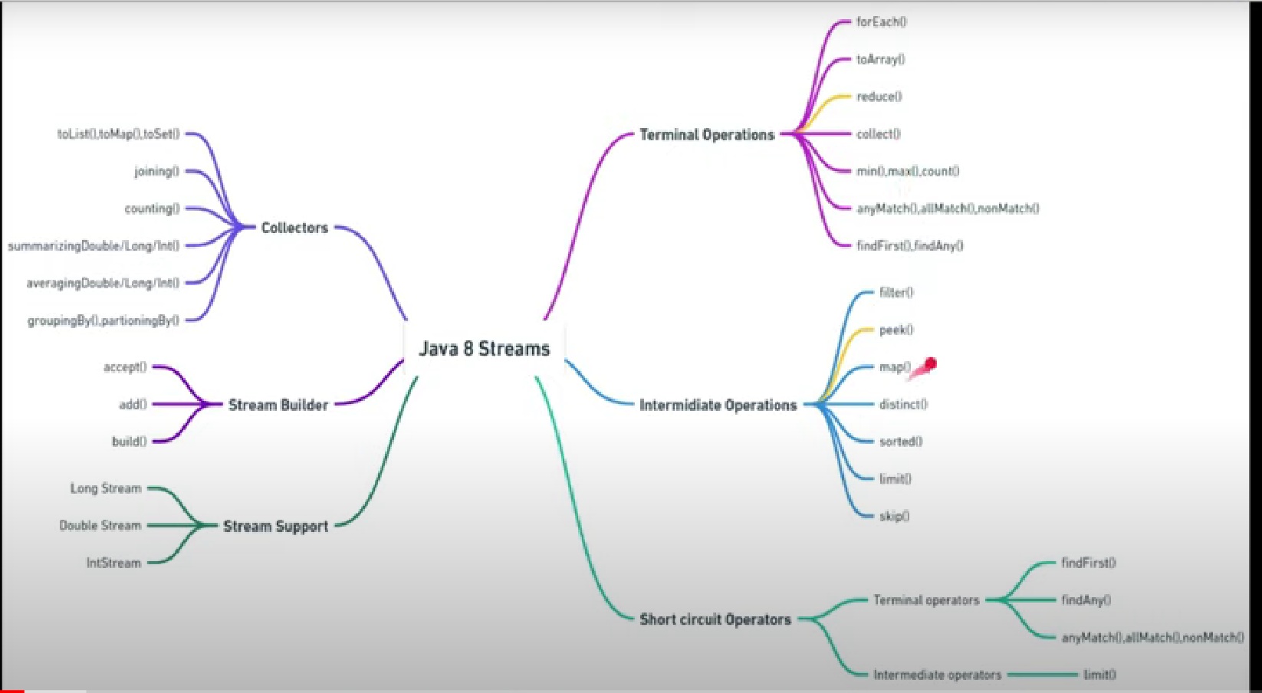
Intermediate Operations:
These operations return streams and the statements will be executed only if have any terminal operations.
Stream<Numbers> streamNumbers=numbers.stream().filter(x -> x%2 ==0).map( x -> { System.out.println(“Inside map method”); return x;});
IF we try to run the above code the statement inside map method won’t be displayed.
streamNumbers.foreach(System.out::println);
If we try to run the above code the statement Inside the map will be displayed and the numbers also.
Terminal VS Intermediate Operations
Intermediate Operations | Terminal Operations
They return stream | They return non-stream values
They can be chained together to form a pipeline of operations | They can’t be chained together
Pipeline of operations may contain any number of intermediate operations | Pipeline of Operations can have maximum one terminal operations, that too at the end
Intermediate operations are lazily loaded | Terminal operations are eagerly loaded
They don’t produce end result | They produce end result

What is Peek
- Stream peek() method is an Intermediate operation
- It takes Consumer object as input
- It returns a Stream consisting of elements of current stream
- It additionally performs the provided action on each element of the stream
Use of Peek
Peek() exists mainly to support debugging where we want to see the elements as they flow past a certain point in a pipeline.
It is similar to Map, but it takes consumer object and perform some action on object and return nothing. But Map takes a function argument hence apply operation on each element and return the stream having modified elements.
Stream<String> numbers = Stream.of(“one”, “two”, “three”, “four”);
numbers.filter(x -> x.length() > 3)
.peek(x -> System.out.println(“Filtered value :”+x))
.map(String::toUpperCase)
.peek(x -> System.out.println(“Mapped value : “+x))
.collect(Collectors.toList());

What is Reduce
- The stream Reduce() combine elements of Stream and produces a single value
- Reduce operation applies a binary operator on each element of the stream where the first argument to the operator is return value of previous application and second value is the current stream element.
Stream<Integer> numbers = Streams.of(1,2,3,4,5);
numbers.reduce((a,b) -> a+b).get();

what is the diff between limit and skip. Explain with example
- The limit() method is an Intermediate operation that return a stream not longer than requested size. The n parameter can’t be negative. If its negative then it throws IllegalArgumentException.
- The skip() method is an Intermediate operation that discards first n elements and returns the remaining as a stream. The n parameter can’t be negative. If parameter value is higher than stream then it returns an empty stream.
How Flat Map works in java 8
- Is the combination of a map and a flat operation
- This means you first apply the map function and then flattens the result. The key difference is the function used by map operation returns a Stream of values or a list of values rather than a single value, that's why we need flattening. When you flat a Stream of Stream, it gets converted into Stream of values.
- To understand what flattening a stream consists in, consider a structure like [ [1,2,3],[4,5,6],[7,8,9] ] which has "two levels". It's basically a big List containing three more List. Flattening this means transforming it in a "one level" structure e.g. [ 1,2,3,4,5,6,7,8,9 ] i.e. just one list.
E.g The Employee class has List of cities worked for a particular employee and we can have list of employees. Suppose we need Single list of all cities employees worked then we have to use flatmap only.

Short Circuit Operations
Java 8 stream intermediate and terminal operations both can be short circuiting. Intermediate - limit() Terminal - findFirst(), findAny(), anyMatch(), allMatch(), noneMatch()
Limit() --. Used to limit the elements of a given list. If We need only particular 10 size elements then use limit(10); Once 10 elements reached remaining elements are short-circuited means skipped.
findFirst() - Find the first occurrent of the given condition in the collection and found then ignore the remaining items. The result is idempotent.
findAny() – Find the occurrence parallelly and return once found the data. The result may not be idempotent.
allMatch() – Takes a predicate as parameter and evaluate the predicate. If any one element false then it return false and skip the remaining elements. Similar to && operator.
anyMatch() – Takes a predicate as parameter and evaluate the predicate. If any one element true then it return true and skip the remaining elements.
Similar to || operator.
noneMatch() – Takes a predicate as parameter and evaluate the predicate. If any one element satisfies predicate, then immediately return false and ignore remaining elements.

Why Optional Objects
- Java Optional class provides a way to deal with null values. It is used to represent a value is present or not. Java 8 added a new class Optional available in java.util package.
- A NullpointerException is common issue in Java applications. To prevent this we normally add frequent NULL check in our code if variable is empty or not before we use it in our program. Optional class provides a better approach to handle situations.
- You can view Optional as a single-value container that either contains a value or not (it is then said to be “empty”).
Returning value with get()
- get() can only return a value if the wrapped object is not null; otherwise it throws no such element exception.
- This is major flow of the get() method. Ideally, Optional should help us avoid such unforeseen exceptions.
Example: findById(int id)
repo.findbyId(id).get();
if we pass any ID whose value is not there in Employee table then we can get No such element exception since we didn’t handle get method properly.
Table: employee. Columns – ID, name (contains null value)
Checking value presence
- When we have an Optional object returned from a method or created by us, we can check there is a value or not with the isPresent() method
- This method returns true if the wrapped value is not null.
- As of Java 11, we can do the opposite with the isEmpty() method.
Creating Optional Objects
- We can create optional object with Optional’s static method of().
- The argument passed to of() method can’t be null. Otherwise, we’ll get a NullPointerException.
- But in case, if we expect some values, we can use isNullable() method
- By doing this, if we a pass a null reference, it doesn’t throw an exception rather returns an empty Optional object.
Conditional Action with ifPresent()
- Given an Employee table, fetch the employee with given id and print its name in upper case. If name is null print “The name is null”, using java8.
Code:
Optional<Employee> e = repo.findById(id);
If(e.isPresent()){
Optional<String> name= Optional.ofNullable(e.get().getName());
If(name.isPresent()){
Return new ResponseEntity(name.get().toUpperCase(), HttpStatus.OK);
}else{
Return new ResponseEntity(“The Name is null”, HttpStatus.NOT_FOUND):
}else{
Return new ResponseEntity(“Sorry Employee with given ID is not present” , Httpstatus.NOT_FOUND);
}
Default value with orElse()
- The orElse() method is used to retrieve the value wrapped inside an Optional instance. It takes one parameter, which acts a default value.
- String name = Optional.ofNullable(nullName).orElse(“Anonymous”);
Difference between orElse() and orElseGet()
- Notice that when using orElseGet() method to retrieve the wrapped value, the callMe() method is not even invoked since the contained value is present.
- In case of orElse() method, still the function is called and default object is being create, which will be never used as the value is present for the variable wrapped in Optional object. But orElseGet() works just fine, the functional interface is never even invoked.
- If the not null case calling the method which again calls web service call or even database query then the performance is worst if we use orElse() method.

Exceptions with orElseThrow()
- Given an Employee table fetch the employee object with Id and return the name in upper case, but if the name is not present throw an exception to stop program using java8
- The orElseThrow() method follows from orElse() and orElseGet() method and adds a new approach for handling an absent value.
- Instead of returning a default value when the wrapped value is not present, it throws an exception:
String name = Optional.ofNullable(e.get().getName()).orElseThrow( () -> new IllegalArgumentException(“The id sent has no name”));

